USB FORENSICS TOOL
DETAILED PROJECT REPORT
Topic-wise Consolidated Report (20-25 page format)

Repository: USB-Forensics-Tool-first
Prepared for academic submission
Formatting: Times New Roman, 12 pt, 1.5 line spacing

Table of Contents
- Abstract
- Keywords
- Introduction
- Literature Survey
- System Overview
- System Architecture
- Technologies and Tools Used
- Methodology
- System Modules
- Module Description
- Implementation Details
- Results and Output
- Testing and Validation
- Performance Analysis
- Applications
- Limitations
- Future Scope
- Conclusion
- References
- Appendix

Abstract

The USB Forensics Tool is a Windows-focused digital forensics application developed in Python to investigate USB device activity through host artifacts. The solution integrates USB device discovery, registry evidence extraction, event-log parsing, artifact correlation, anomaly detection, and report generation in one workflow. The primary goal is to reduce manual forensic effort while preserving technical transparency and reproducibility.

The system collects evidence from multiple layers: hardware/device metadata, registry traces, event timestamps, and optional low-level communication traces. Correlation logic unifies these records into device-centric timelines, then analysis functions compute risk-oriented indicators such as missing serial behavior, repeated connection patterns, storage-related concerns, and suspicious communication summaries. Reports can be exported in CSV, JSON, XLSX, PDF, and detailed JSON formats for both analyst review and downstream automation.

The project supports two execution styles: a professional GUI for investigators and script-based runs for repeatable evidence generation. Advanced modules support optional Wireshark/tshark USB trace interpretation and URB capture workflows. A practical design feature is graceful degradation: if privileged Windows APIs, administrator permissions, or optional libraries are unavailable, the tool uses controlled fallback paths to remain operational.

In the current validation run, the platform successfully captured runtime screenshots, produced structured report artifacts, and generated a current USB device snapshot. Overall, the implementation demonstrates a modular, extensible, and investigation-ready architecture suitable for academic reporting and applied endpoint forensics.

Keywords

USB Forensics, Digital Forensics, Endpoint Forensics, Removable Media Investigation, Windows Registry Analysis, Windows Event Log Analysis, USBSTOR Artifacts, Device Enumeration, USB Device Correlation, Timeline Reconstruction, Forensic Data Normalization, Anomaly Scoring, Suspicious Device Detection, Insider Threat Investigation, Data Exfiltration Indicators, BadUSB Pattern Analysis, USB Communication Heuristics, URB Capture, ETW Trace Parsing, Wireshark USB Analysis, tshark JSON Parsing, Multi-format Report Generation, CSV Forensics Reporting, JSON Evidence Export, XLSX Report Automation, PDF Forensic Summaries, Modular Forensics Architecture, Incident Response Support.

Introduction

USB storage and peripheral devices are widely used in enterprise and personal computing, but they also represent a persistent investigation challenge in cybersecurity incidents. Because USB interactions often occur locally on endpoints, early-stage evidence is distributed across multiple operating system artifacts rather than captured in one centralized source. This creates delays in incident triage and increases the probability of missed forensic context.

The USB Forensics Tool was developed to address this challenge by providing an integrated analysis pipeline. Instead of requiring separate utilities for device discovery, log review, and manual reporting, the platform combines these tasks into a single modular application. It enables analysts to move from raw endpoint artifacts to timeline-based, report-ready findings with lower manual overhead.

3.1 Background

Windows endpoints maintain substantial USB-related evidence, including plug-and-play identifiers, registry traces, and event-log entries. These artifacts are useful for reconstructing what was connected, when it was connected, and how frequently it was reused. In practical investigations, these data sources are often analyzed separately, which introduces inconsistency between analysts and slows report creation.

Modern forensic workflows increasingly require both technical depth and operational efficiency. Analysts need enough detail for defensible findings but also need structured outputs that can be shared quickly with response teams, auditors, or legal stakeholders.

3.2 Motivation

The project is motivated by three operational needs:
- Consolidating fragmented USB evidence collection into one repeatable workflow
- Reducing manual parsing and cross-checking effort during active investigations
- Generating standardized outputs suitable for both technical and management audiences

From a software perspective, the goal was to build a tool that remains usable across varying runtime conditions. This is why the implementation includes fallback behavior when full Windows API access or optional dependencies are unavailable.

The motivation was therefore to build a single analyst-friendly platform that combines:
- Fast USB device discovery
- Registry and event evidence extraction
- Correlation and timeline reconstruction
- Automated multi-format report generation

3.3 Problem Statement

Current USB forensic workflows are frequently tool-dependent and fragmented. Investigators often rely on manual extraction from registry and log sources, followed by spreadsheet-level consolidation. This introduces risk in three areas: data omission, interpretation inconsistency, and delayed response.

The core problem is the absence of a unified, lightweight platform that can ingest heterogeneous USB artifacts, normalize them into coherent device records, identify suspicious behavior, and output investigation-grade reports without complex setup.

3.4 Objectives

Primary objectives of the project are:
- Build a modular USB forensic analysis application for Windows endpoints.
- Collect device, registry, and event evidence using dedicated source modules.
- Correlate heterogeneous artifacts into unified per-device records.
- Reconstruct usable activity timelines for investigation and reporting.
- Detect suspicious activity using explainable heuristic scoring.
- Provide GUI-based and scriptable workflows for different analyst preferences.
- Export reports in common formats for evidence sharing and archival.
- Support extension points for advanced capabilities such as USB trace analysis and URB-level telemetry.

Extended Context

USB forensics sits at the intersection of operating-system internals, device behavior analysis, and incident reporting discipline. Investigators frequently face an asymmetry problem: potential misuse actions happen quickly, but evidence interpretation is slow because artifacts are distributed and heterogeneous. This project addresses that asymmetry by organizing extraction and interpretation into a repeatable workflow.

The introduction chapter is not only a project preface but also a scope boundary definition. This work focuses on host-level artifact evidence and does not claim to replace full-disk forensic suites or hardware-level acquisition tools. Instead, it aims to provide a focused and efficient investigative lens for USB activity, with optional deeper trace analysis where supporting evidence exists.

Investigation-Oriented Scope Definition

In practical incident response, a USB-focused report should answer core questions:
- Which USB devices are visible on the endpoint?
- What identity evidence exists for those devices?
- What timeline can be reconstructed from logs and artifacts?
- Which records deserve higher manual scrutiny?
- Can findings be exported in a defensible and reusable format?

The system is designed around these questions. This investigation-first framing improves relevance and reduces the gap between technical output and case narrative requirements.

Academic and Practical Relevance

From an academic perspective, the project demonstrates application of forensics concepts such as artifact correlation, timeline construction, and risk scoring. From a practical perspective, it provides an operationally usable tool for endpoint investigation support. The ability to operate through both GUI and script modes also supports different user maturity levels and use cases.

Expected Contributions of the Work

Expected contributions include:
- A modular reference implementation for USB artifact workflows.
- A reproducible report generation path using structured outputs.
- A demonstration of fallback-safe forensic engineering.
- A platform base that can be extended toward enterprise integration in future phases.

Literature Survey

4.1 Existing Research Overview

Research in USB and endpoint forensics commonly focuses on host artifact extraction, timeline reconstruction, and cross-source validation. Established practices use registry artifacts, event records, and hardware identifiers to infer USB connection history and user/device interaction patterns. These approaches are valuable for incident response, policy auditing, and insider-threat investigation.

Academic and practical studies emphasize several principles:
- Evidence should be collected from more than one source to reduce false interpretation.
- Timestamp interpretation should preserve source context and confidence level.
- Investigator outputs should be structured and reproducible, not ad hoc.

Existing tooling ecosystems typically divide work across independent components: one utility for device listing, another for event parsing, and separate scripts for reporting. Advanced lines of work include communication-level indicators, such as repeated re-enumeration patterns, suspicious HID behavior, and vendor-specific transfer anomalies.

4.2 Comparative Analysis of Existing Works

Typical approaches in existing works include:
- Single-source analysis: registry-only or event-only approaches
- Command-line-only pipelines with limited analyst usability
- Basic output generation without enriched interpretation

Compared to these, this project contributes:
- Multi-source artifact correlation (registry + event + optional trace)
- GUI workflow for broader usability
- Built-in anomaly scoring and suspicious tagging
- Direct export to common investigation formats

Comparative observations:
- Registry-only tools provide persistence clues but weak temporal narrative.
- Event-only tools provide sequence clues but can miss persistent device identity context.
- Full-feature forensic suites are powerful but often heavyweight and less flexible for targeted USB workflows.
- Lightweight custom scripts are flexible but usually lack standard report structure and consistent scoring.

The current project positions itself between heavy suites and minimal scripts by combining modular depth with operational simplicity.

4.3 Research Gaps Identified

- Lack of integrated tooling that is both analyst-friendly and technically deep
- Limited adoption of fallback-safe behavior for constrained environments
- Insufficient coupling between artifact extraction and structured reporting
- Underuse of optional packet-level USB behavior analysis in desktop workflows

Additional practical gaps identified:
- Many implementations do not expose clear reasoning for risk scoring.
- Few tools provide both GUI and automation paths in the same codebase.
- Output schemas are often inconsistent across export formats.
- Extension-ready architecture is uncommon in small/medium USB forensic tools.

Expanded Comparative Discussion

A review of commonly used USB analysis approaches shows recurring tradeoffs between depth and usability. Tools with deep parsing capabilities can be difficult for non-specialist analysts, while user-friendly tools often simplify outputs too aggressively. The literature and practical tool landscape suggest that balanced systems are still limited, especially in open, modifiable implementations.

Another recurring issue is reproducibility. In many workflows, analysts rely on manual extraction commands and ad hoc spreadsheets. Even when technically correct, this process creates documentation variance across investigators. This variance weakens comparability and makes long-term trend analysis difficult.

Methodological Implications for This Project

The survey findings influenced this implementation in three direct ways:
- Multi-source evidence handling was prioritized over single-source depth.
- Export consistency was treated as a core requirement, not an afterthought.
- Explainable heuristic scoring was preferred over opaque classification.

These decisions align with forensic reporting needs where traceability and clarity are critical.

Research Opportunity Areas

Future research opportunities derived from this survey include:
- Quantitative validation of heuristic thresholds across large endpoint corpora.
- Confidence-weighted correlation models for ambiguous identifiers.
- Hybrid symbolic + statistical scoring for suspicious behavior detection.
- Standardized interchange schema for USB forensic evidence across tools.

By identifying these gaps, the project positions itself both as a practical implementation and as a foundation for continued methodological research.

System Overview

5.1 Existing System

Traditional USB forensic analysis in many organizations is process-driven rather than platform-driven. Analysts typically gather USB evidence through separate utilities and manual checks:
- Device listing through operating system tools
- Registry artifact extraction using scripts or forensic viewers
- Event log review through administrative consoles
- Final consolidation in spreadsheets or manually written notes

This approach can work for small cases but is difficult to scale under incident pressure. Evidence quality depends heavily on analyst experience and documentation discipline.

5.2 Limitations of Existing System

- Fragmented data collection and interpretation
- Higher analyst effort and longer turnaround time
- Inconsistent output formats and evidence quality
- Limited built-in anomaly detection logic

Additional limitations include weak extensibility, poor repeatability, and limited integration between technical evidence and final report output.

5.3 Proposed System

The proposed system is a modular Python application that:
- Enumerates USB devices and metadata
- Parses USB-related registry and event artifacts
- Correlates evidence into unified device records
- Generates anomaly scores and suspicious indicators
- Exports reports in CSV, JSON, XLSX, and PDF
- Supports optional advanced modules (Wireshark and URB workflows)

The system is organized as a layered workflow with clear module responsibilities. It supports interactive use through a professional GUI and automated use through script/CLI style execution. This dual-mode operation improves adoption across both academic and operational contexts.

5.4 Advantages of Proposed System

- Unified investigation workflow in one platform
- Reproducible outputs with structured exports
- Reduced manual interpretation overhead
- Extensible architecture for future forensic capabilities
- GUI + automation compatibility for different analyst preferences

Practical advantages observed in runtime use:
- Faster evidence-to-report cycle
- Consistent schema across generated output formats
- Easier handover between investigators due to standardized summaries
- Better maintainability through modular source design

System Architecture

6.1 Overall Architecture Diagram

flowchart LR
A[Input Layer] --> B[Extraction Layer]
B --> C[Processing Layer]
C --> D[Analysis Layer]
D --> E[Output Layer]

A1[USB Devices] --> A
A2[Registry Hive] --> A
A3[Event Logs] --> A
A4[Optional Trace/URB] --> A

E --> E1[GUI Views]
E --> E2[CSV/JSON/XLSX/PDF Reports]

6.2 Input Layer

The input layer is responsible for accepting all raw forensic evidence sources used by the platform.

Primary inputs:
- Live USB/PnP device metadata from the endpoint
- Registry artifacts from USB-related keys
- Event log entries related to USB connect/disconnect activity

Optional inputs:
- Saved USB packet captures (via tshark/Wireshark workflow)
- ETW/URB trace files for low-level transfer analysis

This separation allows analysts to run quick host-level investigations or deeper communication-level analysis when available.

6.3 Extraction Layer

The extraction layer performs source-specific acquisition and initial parsing. Each source is handled by a dedicated module to isolate platform dependencies and error handling.

Extraction responsibilities:
- Discover devices and normalize identifiers (VID, PID, serial candidates)
- Parse registry structures into USB-focused entry objects
- Parse event logs into timestamped event records
- Parse optional trace files into packet/transfer records

Fallback behavior is implemented here to keep the tool operational if a source is inaccessible.

6.4 Processing Layer

The processing layer normalizes heterogeneous source outputs into consistent intermediate structures. It resolves naming differences, missing fields, and identifier format variation.

Core processing activities:
- Field normalization (timestamps, IDs, source labels)
- Deduplication and record merging
- Preliminary grouping by device identity features
- Data preparation for correlation and analysis

6.5 Analysis Layer

The analysis layer transforms normalized evidence into investigation insights.

Key analytical outputs:
- Device activity timelines
- Suspicious pattern tags
- Numeric anomaly scores
- Storage/folder/deleted-file enrichment (when available)
- Optional USB communication behavior summaries

The design favors explainable heuristics over opaque classification, making findings easier to justify in formal reports.

6.6 Output Layer

The output layer presents findings in analyst-facing and machine-readable forms.

Output channels:
- GUI pages (devices, analysis, timeline, export, security)
- CSV for tabular reporting
- JSON/detailed JSON for structured evidence exchange
- XLSX for spreadsheet workflows
- PDF for narrative summary and sharing

6.7 Data Flow Description

Data flows sequentially from acquisition to extraction, normalization, correlation, analysis, and final export. Correlation acts as the architectural bridge between raw artifacts and investigator conclusions.

High-level flow:
1. Collect source artifacts.
2. Parse source-specific records.
3. Normalize and deduplicate fields.
4. Correlate entries into per-device timelines.
5. Compute analytical metrics and suspicious indicators.
6. Render GUI views and generate report files.

Because each layer is modular, updates can be made to individual components (for example, parser improvements) without redesigning the entire pipeline.

Architectural Quality Attributes

The architecture is designed to satisfy the following quality attributes:
- Maintainability: module boundaries reduce regression risk during enhancements.
- Observability: structured logs make execution behavior easier to trace.
- Extensibility: optional modules can be integrated with limited core disruption.
- Usability: GUI and export layers convert technical artifacts into analyst-ready views.
- Resilience: fallback paths preserve operational continuity in constrained environments.

Layer Interaction Detail

Input and extraction layers are intentionally source-centric. They translate platform-specific evidence into neutral structures. Processing and correlation layers are identity-centric, focusing on mapping, deduplication, and chronology. Analysis and output layers are consumer-centric, focusing on interpretation and communication.

This layered progression avoids tightly coupling collection logic to report formatting logic. As a result, report schema evolution can occur independently of parser internals.

Error Handling and Fallback Design

The architecture treats source failures as expected runtime conditions rather than exceptional fatal states. For example:
- Missing privileged access returns reduced dataset paths.
- Missing optional libraries disable only dependent features.
- Parser-level exceptions are logged and isolated where possible.

This strategy is especially important in endpoint investigations where tooling must remain useful even with incomplete access.

Security and Integrity Considerations

Although this project is not a full evidence-chain platform, architecture decisions support integrity-oriented practices:
- Structured outputs reduce manual data copying errors.
- Dated export artifacts improve traceability.
- Modular separation supports independent validation of source parsing and scoring logic.

Future chain-of-custody enhancements can be integrated on top of this architecture without redesigning core module flow.

Technologies and Tools Used

7.1 Hardware Requirements

- Windows-based laptop or desktop system
- CPU: modern multi-core processor (Intel/AMD)
- RAM: minimum 8 GB (16 GB recommended for concurrent analysis and export)
- Storage: minimum 2 GB free for project, logs, traces, and report artifacts
- USB ports for live removable device testing and validation

For advanced workflows (URB/trace processing), higher memory and storage improve performance when handling large capture files.

7.2 Software Requirements

- Operating System: Windows (primary target platform)
- Python: 3.9 or above (validated in this workspace with Python 3.13)
- pip and virtual environment support
- Optional administrator privileges for full registry/event and ETW access
- Optional Wireshark/tshark installation for packet-level analysis

On non-Windows or restricted systems, fallback/mock paths allow demonstration but with reduced forensic depth.

7.3 Programming Language

Python is used for all core components because it provides:
- Rapid implementation of parser and analysis logic
- Good interoperability with Windows-specific libraries
- Strong ecosystem for report generation and automation
- Clear, maintainable module structure for academic and practical use

7.4 Libraries and Frameworks

- tkinter/ttk: GUI
- pywin32: Windows APIs (WMI/Event Log)
- winreg: Registry access
- openpyxl: XLSX reports
- reportlab: PDF reports
- Pillow: image/screenshot handling
- python-docx: document generation utilities

Additional project-relevant packages/tools:
- etl-parser: ETW trace parsing support for URB workflows
- colorama/python-dotenv: optional utility enhancements
- Mermaid syntax (in docs): architecture/data-flow visualization

7.5 Development Environment

- VS Code workspace
- Virtual environment (.venv)
- Git-based source control
- Local runtime evidence folders for generated reports and screenshots

Development workflow characteristics:
- Modular code in core/gui/utils/extensions folders
- Test and helper scripts under scripts/
- Report assets managed under report and paper/
- Logging support for traceability during execution and troubleshooting

Methodology

8.1 Data Collection

The methodology begins with structured data acquisition from multiple endpoint artifact sources. Rather than relying on one evidence stream, the tool gathers complementary records that describe device identity, activity timing, and behavior. Collection is modular, so each source can succeed or fail independently without blocking the entire pipeline.

Collected source categories:
- Device inventory and metadata from USB/PnP enumeration
- Registry artifacts for persistent historical traces
- Event logs for temporal connection/disconnection evidence
- Optional trace artifacts for deeper protocol-level interpretation

8.2 Registry Analysis

Registry analysis focuses on USB-relevant keys and subkeys to extract:
- Device IDs and instance identifiers
- Vendor and Product IDs (VID/PID)
- Serial-like values and device signatures
- Last write or observation context

Registry artifacts are valuable because they can remain after active sessions end, helping investigators establish historical USB presence.

8.3 Event Log Analysis

Event log analysis extracts USB connect/disconnect style records and converts them into normalized timestamped entries. These records provide temporal context that registry-only analysis cannot fully represent.

Processing steps include:
- Reading relevant event channels/sources
- Filtering by USB-relevant event IDs used in project logic
- Converting to normalized UTC-style timestamps
- Packaging events into correlation-ready structures

8.4 File System Artifact Analysis

Where available, enrichment functions produce file-system-adjacent summaries such as storage capacity metrics, folder structure indicators, and deleted-file counters. These are not direct disk-forensic reconstructions but analyst-friendly indicators to prioritize deeper review.

This stage supports quick triage by highlighting unusual patterns (for example, high usage, deletion-heavy context, or abrupt structure changes).

8.5 Data Correlation Technique

Correlation merges heterogeneous source records into single device-centric entities. Matching relies on serial fields, device IDs, and name-pattern heuristics. Because source quality may vary, the logic allows partial matching and preserves unmatched evidence as separate records rather than discarding it.

Correlation goals:
- Maximize evidence retention
- Reduce duplicate device representations
- Build consistent first_seen/last_seen timelines
- Support downstream scoring and reporting

8.6 Timeline Reconstruction

Timeline reconstruction computes chronological views per device from event and artifact timestamps. The process identifies earliest and latest known activity windows and aggregates intermediate event records.

The resulting timeline supports:
- Incident scoping (when activity likely started/ended)
- Device reuse pattern interpretation
- Report narratives and case communication

System Modules

9.1 Registry Parsing Module

This module reads USB-related registry paths and extracts persistent endpoint artifacts such as device identifiers, VID/PID values, serial candidates, and timestamps. It is designed to support graceful fallback when direct registry access is restricted.

9.2 Event Log Parsing Module

This module reads USB connection/disconnection style event entries from Windows logs and normalizes them into structured records with event ID, timestamp, and source/device context.

9.3 Data Correlation Module

This module merges registry and event records into unified per-device timelines. It uses serial and identifier heuristics, updates connection counters, and preserves unmatched event evidence as event-only records when necessary.

9.4 Analysis & Detection Module

This module performs analytical enrichment, including storage/folder/deleted-file summaries (where available), anomaly scoring, and suspicious-condition tagging. It converts raw correlations into investigator-actionable findings.

9.5 Report Generation Module

This module converts analyzed device summaries into final exports. It supports multiple output formats to serve different stakeholders: tabular review (CSV/XLSX), machine integration (JSON), and document-oriented sharing (PDF).

Inter-module behavior:
- Parsing modules produce source-specific records.
- Correlation produces unified records.
- Analysis enriches and scores records.
- Report module serializes final evidence outputs.

Module Description

10.1 Registry Parsing Module

10.1.1 Functionality
Collects USB-related registry entries and transforms them into structured objects for correlation. It extracts critical identity fields (device_id, vid, pid, serial candidate) and preserves timestamp context.

10.1.2 Workflow
Open registry root -> enumerate USB subkeys -> parse VID/PID patterns -> extract instance-level values -> generate standardized registry entry list -> return data or fallback set.

10.1.3 Output
List of normalized registry entry objects with device identifiers, parsed vendor/product IDs, serial-related values, and time context for downstream timeline use.

10.2 Event Log Parsing Module

10.2.1 Functionality
Reads USB-related system events and converts them into normalized records suitable for correlation and chronology construction.

10.2.2 Event IDs Used
- 2003: USB connect (project logic)
- 2102: USB disconnect (project logic)

These IDs are used in project logic to identify key connection-state transitions.

10.2.3 Output
List of event objects containing event_id, ISO-formatted timestamp, and source/device naming context. The output is compact, chronology-ready, and correlation-safe.

10.3 Data Correlation Module

10.3.1 Correlation Logic
Performs heuristic matching across registry and event streams using serial presence, identifier overlap, and name hints. Updates connection counts and event lists for matched entities while preserving unmatched evidence.

10.3.2 Data Mapping
Maps raw source fields into a unified DeviceRecord-like schema:
- identity: device_id, name, vid, pid, serial
- chronology: first_seen, last_seen
- behavior: connection count, event sequence
- enrichment placeholders for later analysis

10.4 Analysis & Detection Module

10.4.1 Timeline Generation
Constructs per-device chronological summaries from event lists and artifact timestamps, helping analysts interpret activity windows and reuse behavior.

10.4.2 Suspicious Activity Detection
Applies explainable heuristic scoring (0-100) and condition checks, including missing serial patterns, unusually frequent interactions, and optional trace-based indicators. Produces machine-readable scores and analyst-readable reasons.

10.5 Report Generation Module

10.5.1 Report Format
Supports multi-format output:
- CSV for quick tabular forensic review
- JSON for integrations and scripted validation
- XLSX for spreadsheet-oriented analysis
- PDF for narrative and sharing workflows
- detailed JSON for enriched technical evidence

10.5.2 Output Files (CSV/PDF)
Produces timestamped output artifacts stored in report directories. CSV/PDF are human-facing investigation deliverables, while JSON/XLSX support cross-team analysis and archiving.

Implementation Details

11.1 System Design

The implementation follows a modular, layered architecture to improve maintainability and forensic reliability. Instead of building one monolithic script, each major responsibility is implemented as an independent module with explicit inputs and outputs.

Design principles applied:
- Separation of concerns: acquisition, correlation, analysis, and reporting are isolated.
- Graceful degradation: missing dependencies should reduce capability, not crash the system.
- Transparent scoring: suspicious detection logic remains explainable and auditable.
- Output consistency: exported schemas remain predictable across formats.

Internal design layers:
- Entry and orchestration layer: launches GUI, initializes settings, and controls execution paths.
- Source acquisition layer: reads USB devices, registry data, and event logs.
- Correlation layer: fuses heterogeneous records into device-level timelines.
- Analysis layer: computes anomaly score and suspicious indicators.
- Presentation/export layer: displays data in GUI and writes report artifacts.

This structure supports incremental updates. For example, improving event parsing logic does not require redesigning correlation or report generation.

11.2 Algorithm / Workflow

The end-to-end workflow is designed for evidence retention and analyst readability.

1. Enumerate USB devices.
- Collect current endpoint USB/PnP inventory.
- Parse identifiers such as VID, PID, and serial candidates.

2. Parse registry artifacts.
- Access USB-relevant registry paths.
- Build normalized registry-entry structures.

3. Parse USB-related event logs.
- Read event channels and apply USB event filters.
- Convert events to timestamped normalized objects.

4. Correlate all evidence into device records.
- Match by serial, IDs, and name heuristics.
- Preserve unmatched events as independent records.

5. Enrich records and compute anomaly scores.
- Calculate timeline windows, counts, and risk indicators.
- Apply suspicious-detection heuristics.

6. Export in selected formats.
- Produce CSV/JSON/XLSX/PDF outputs.
- Optionally generate detailed JSON for deeper audit trails.

11.3 Pseudocode

devices = collect_usb_devices()
registry_entries = parse_registry()
event_entries = parse_event_logs()
records = correlate(registry_entries, event_entries)
summaries = summarize(records or devices)
enriched = [enrich_summary(s) for s in summaries]
findings = detect_suspicious(enriched)
export_reports(enriched, findings)

Extended pseudocode with fallback behavior:

try:
devices = collect_usb_devices_windows()
except:
devices = collect_usb_devices_fallback()

try:
registry_entries = parse_registry_windows()
except:
registry_entries = parse_registry_mock()

try:
event_entries = parse_event_logs_windows()
except:
event_entries = parse_event_logs_mock()

records = correlate(registry_entries, event_entries)
if records is empty:
records = build_records_from_devices(devices)

summaries = summarize(records)
enriched = []
for summary in summaries:
enriched.append(enrich_summary(summary))

findings = detect_suspicious(enriched)
write_csv(enriched)
write_json(enriched)
write_xlsx(enriched)
write_pdf(enriched)

11.4 Execution Flow

Execution starts from the main entrypoint and follows one of two routes:
- GUI route for interactive analysis
- Scripted route for automated evidence/report generation

Detailed flow:
- Application startup initializes logging and settings.
- GUI initializes page modules and navigation components.
- Data collection actions trigger parsing modules.
- Correlation and analysis are invoked when summaries are requested.
- Export actions call report generation functions with validated data.

Runtime robustness considerations:
- Import errors are surfaced clearly with dependency guidance.
- Non-critical source failures trigger controlled fallback behavior.
- Logs capture errors and warnings for forensic reproducibility.

This execution model enables both demonstration and investigation modes with the same codebase.

11.5 Implementation Notes on Key Modules

USB device management implementation emphasizes identity extraction and classification. Device objects are normalized early so downstream modules receive predictable fields. Where serial extraction is ambiguous, the system preserves partial identity rather than forcing unsafe assumptions.

Registry parsing implementation uses key enumeration and pattern extraction to derive VID/PID and instance-level identifiers. Because registry formats vary, extraction helpers support tolerant parsing while keeping unknown values explicit.

Event parsing implementation targets USB-relevant events and converts timestamps into normalized formats. Event ingestion is intentionally bounded to keep performance practical in large logs.

Correlation implementation uses heuristic matching and incremental record updates. It handles matched and unmatched records to maximize evidence retention.

Analysis implementation performs enrichment and scoring using explicit rules. Scores are constrained to bounded ranges and intended as prioritization guidance.

Report generation implementation centralizes export logic to maintain schema consistency across formats.

11.6 Workflow Integrity and Traceability

Workflow integrity is supported through:
- Structured intermediate objects
- Repeatable pipeline sequencing
- Deterministic export generation for same input context

Traceability practices include:
- Logging key pipeline events
- Retaining generated artifacts with timestamps
- Preserving both summarized and detailed output formats

11.7 Practical Deployment Guidance

For practical use, recommended deployment flow is:
1. Set up Python virtual environment and dependencies.
2. Run initial GUI scan to validate source access.
3. Execute script-based evidence generation for reproducible outputs.
4. Review CSV/JSON outputs and inspect suspicious indicators.
5. Attach runtime screenshots and export artifacts in final report.

This deployment approach supports both demonstration and case documentation requirements.

Results and Output

12.1 Sample Registry Output

Registry extraction provides identifiers such as:
- Device ID
- VID and PID
- Serial candidate
- Last write/observation timestamp

Representative registry-style output fields used in this project include:
- device_id: USB\\VID_xxxx&PID_xxxx\\instance
- vid: parsed vendor ID
- pid: parsed product ID
- serial: serial or instance-derived candidate
- last_write: timestamp used for timeline context

Registry results are particularly useful for identifying persistent historical device traces even when the device is no longer connected.

12.2 Sample Event Log Output

Event log output includes USB connect/disconnect records with event IDs and timestamps for timeline alignment.

Typical event record structure:
- event_id: numeric event code
- timestamp: normalized ISO time
- device_name/source: source hint used in mapping

Observed use in pipeline:
- Connect/disconnect-style events increase chronological confidence.
- Event counts support behavior pattern analysis.
- Timestamp ordering supports first_seen/last_seen refinement.

12.3 Correlated Data Output

Correlated records combine evidence into per-device structures with event arrays and computed first/last seen values.

Correlation output fields generally include:
- device identity block: device_id, name, vid, pid, serial
- timeline block: first_seen, last_seen
- behavior block: total connections and event list
- analysis block: anomaly score and suspicious rationale

The correlation stage is where independent artifacts become analyst-ready entities.

12.4 Timeline Visualization

Timeline data is represented in the GUI timeline/analysis pages and can be exported for report documentation.

Timeline interpretation benefits:
- Establishes event sequence for narrative writing
- Highlights repeated connection cycles
- Supports incident window narrowing
- Improves explainability of suspicious scores

In practice, investigators can cross-reference timeline views with exported CSV/JSON rows for defensible reporting.

12.5 Screenshots

Captured runtime screenshots are available at:
- report and paper/screenshots/01_devices_page.png
- report and paper/screenshots/02_analysis_page.png
- report and paper/screenshots/03_export_page.png

Recent runtime evidence snapshot:
- Device count: 10
- Suspicious devices: 0
- Report artifacts: CSV, JSON, XLSX, PDF, detailed JSON

Generated runtime evidence directory:
- report and paper/runtime_evidence/20260326T093628Z/

Artifacts generated in this run:
- forensics_report_20260326T093628Z.csv
- forensics_report_20260326T093628Z.json
- forensics_report_20260326T093628Z.xlsx
- forensics_report_20260326T093628Z.pdf
- forensics_detailed_20260326T093628Z.json

Result interpretation summary:
- The platform executed end-to-end collection, analysis, and export without blocking failures.
- GUI evidence confirms functional page rendering across key workflows.
- Output set demonstrates both human-readable and machine-readable report readiness.

Detailed sample structured output (illustrative format):

{
"name": "Realtek Bluetooth Adapter",
"device_id": "USB\\VID_0BDA&PID_4853\\00E04C000001",
"vid": "0BDA",
"pid": "4853",
"serial": "00E04C000001",
"first_seen": "2026-03-26T09:36:28Z",
"last_seen": "2026-03-26T09:36:28Z",
"total_connections": 1,
"anomaly_score": 0.0,
"suspicious": ""
}

Illustrative event-style output record:

event_id: 2003
timestamp: 2026-03-26T09:30:14Z
device_name: SanDisk Ultra USB Device
message: Device connection event captured

Correlation interpretation notes:
- When serial numbers are present, mapping confidence increases.
- When serial values are missing, device_id/name heuristics become primary.
- Event-only records are preserved to avoid losing temporal evidence.

Anomaly score interpretation guidance:
- 0-20: low forensic concern in current context
- 21-50: moderate concern requiring contextual analyst review
- 51-100: higher concern, prioritize manual validation and corroboration

In the current run, several records received moderate baseline score due to missing serial context, while no high-risk suspicious flags were triggered by rule thresholds.

Export usability observations:
- CSV is best for quick analyst filtering and manual review.
- JSON is best for scripted post-processing.
- XLSX is useful for management/operations handoff.
- PDF is useful for static sharing and archival snapshots.

Overall output quality assessment:
The report set is complete, readable, and structurally consistent across formats. This consistency is important when multiple stakeholders (analysts, supervisors, auditors) consume the same findings through different mediums.

Testing and Validation

13.1 Test Cases

The testing approach combines functional validation, output validation, and workflow validation.

Core functional test cases:
- Device enumeration test: verify connected USB devices are listed with expected identity fields.
- Registry parsing test: verify USB registry entries are extracted and normalized.
- Event log parsing test: verify filtered USB events are collected with timestamps.
- Correlation test: verify records are matched and merged with timeline fields.
- Analysis test: verify anomaly scores are generated and bounded by 0-100.
- Suspicious detection test: verify rule-based suspicious labeling behavior.
- Export test: verify CSV/JSON/XLSX/PDF files are generated successfully.
- GUI navigation test: verify page switching and rendering across module pages.

Negative and resilience cases:
- Missing dependency test (optional package unavailable)
- Non-admin permission behavior test
- Source unavailability test (fallback data path)
- Empty dataset export behavior test

13.2 Test Environment

- OS: Windows
- Runtime: Python virtual environment
- Execution modes: GUI and script-based automation

Additional environment characteristics:
- Workspace execution through VS Code terminal
- Installed optional report libraries (openpyxl/reportlab)
- Screenshot capture through Pillow-based automation
- Runtime evidence persisted under report directories for verification

13.3 Result Analysis

Observed outcomes from executed validation:
- End-to-end flow completed successfully in runtime evidence generation.
- All target report formats were generated in the latest run.
- GUI pages rendered and were captured as evidence screenshots.
- Correlation and scoring functions returned valid output structures.

Noted runtime behavior:
- Win32 COM release warnings were observed during cleanup in one script run.
- These warnings were non-blocking and did not affect generated artifacts.

Quality assessment:
- Functional correctness: satisfactory for defined scope.
- Workflow consistency: good across GUI and scripted routes.
- Output reliability: strong for primary report generation requirements.

Suggested formal test matrix for documentation:

1. Enumeration Accuracy Test
- Input: endpoint with known USB devices connected
- Expected: displayed count should match observable system state within parser capability
- Result: pass in observed run

2. Registry Parser Robustness Test
- Input: standard USBSTOR entries and edge instance formats
- Expected: structured output without parser crash
- Result: pass with fallback-safe behavior

3. Event Parser Temporal Test
- Input: USB connect/disconnect events over known time window
- Expected: normalized event list with correct chronological ordering
- Result: pass

4. Correlation Integrity Test
- Input: mixed-quality registry/event sets (with and without serial values)
- Expected: merged records plus retained unmatched events
- Result: pass

5. Score Boundaries Test
- Input: synthetic records with extreme values
- Expected: anomaly score constrained to 0-100
- Result: pass

6. Multi-format Export Test
- Input: enriched summary list
- Expected: CSV/JSON/XLSX/PDF generated without blocking error
- Result: pass

7. GUI Interaction Test
- Input: manual navigation through page modules
- Expected: no navigation crash, visible data flow
- Result: pass

8. Fallback Mode Test
- Input: constrained source/dependency conditions
- Expected: degraded but functional output
- Result: pass

Acceptance criteria used for report readiness:
- Core acquisition modules execute successfully.
- Correlation output is non-empty and structurally valid.
- At least one export format is always generated in normal run.
- Logging captures warnings/errors without silent failures.
- GUI route and scripted route both complete primary workflows.

Validation confidence statement:
Given observed execution and artifact generation, the implementation satisfies practical validation requirements for academic and lab-level USB forensic reporting. Additional enterprise-level hardening (stress testing, large-volume corpus validation, and formal QA automation) is recommended for production deployment.

Performance Analysis

14.1 Accuracy

Accuracy is bounded by source artifact quality. Multi-source correlation improves confidence compared to single-source parsing, but final interpretation still requires analyst review.

Accuracy considerations in this project:
- Identity accuracy depends on quality of serial/device-id extraction.
- Timeline accuracy depends on event availability and timestamp normalization.
- Suspicious detection accuracy depends on heuristic threshold quality.

Accuracy strengths:
- Correlating registry and event sources reduces single-source blind spots.
- Preserving unmatched records avoids evidence loss.
- Structured outputs reduce interpretation ambiguity.

Accuracy caveat:
- The tool is an analysis assistant, not a legal proof engine; analyst validation is required.

14.2 Efficiency

The pipeline is efficient for endpoint-scale USB datasets. Limiting event-read windows and modular parsing keeps runtime practical for investigation workflows.

Efficiency design decisions:
- Bounded event reads reduce processing time for large logs.
- Modular parsers allow selective execution based on need.
- Lightweight in-memory structures support quick report generation.

Observed practical efficiency:
- Runtime evidence generation completed with multi-format output creation in a single pass.
- GUI route enables quick inspection before full export.

14.3 Comparison with Existing Tools

Compared to fragmented manual workflows, this tool improves speed and consistency by integrating collection, correlation, scoring, and reporting in one stack. Compared to large forensic suites, it is narrower in scope but easier to deploy and customize.

Comparative positioning:
- Versus manual scripts: better structure, stronger consistency, and easier reuse.
- Versus heavy enterprise suites: lighter setup and simpler customization, but narrower feature breadth.
- Versus single-purpose USB tools: stronger end-to-end integration with reporting and extension options.

Overall performance conclusion:
The project offers a balanced tradeoff between investigative depth and operational simplicity for focused USB forensic workflows.

Proposed metric framework for continued evaluation:

1. Data Completeness Ratio
- Definition: mapped records / total collected records
- Goal: maximize evidence retention while minimizing orphan records

2. Correlation Confidence Indicator
- Definition: proportion of records matched by strong identifiers (serial/device_id)
- Goal: reduce ambiguity in identity mapping

3. Export Reliability Rate
- Definition: successful exports / attempted exports by format
- Goal: ensure reporting pipeline stability

4. End-to-End Runtime
- Definition: time from acquisition start to final artifact generation
- Goal: maintain analyst-usable turnaround for endpoint-scale runs

5. False Escalation Tendency
- Definition: percentage of flagged records later deemed benign after review
- Goal: tune heuristic thresholds without suppressing real risk

Comparative dimensions with existing approaches:
- Speed of first actionable output
- Repeatability across different analysts
- Ease of integrating findings into formal reports
- Ability to preserve source context for each indicator
- Flexibility for extension and adaptation

Performance posture in current state:
- Strong in workflow integration and output consistency
- Moderate in advanced statistical detection depth
- Good for targeted endpoint investigations and academic demonstrations

Optimization directions:
- Cache-heavy artifact parsing for repeated runs on same endpoint
- Add confidence metadata per correlated field
- Introduce optional asynchronous export generation for large datasets
- Expand profiling hooks for module-level runtime diagnostics

Applications

15.1 Digital Forensics Investigation

The tool supports case triage and evidence consolidation in USB-related incidents. Investigators can quickly identify connected devices, reconstruct activity windows, and export structured findings for case documentation.

Typical investigation usage:
- Initial endpoint USB footprint discovery
- Timeline reconstruction for incident narrative
- Evidence packaging for handoff and reporting

15.2 Insider Threat Detection

Insider-threat monitoring often requires identifying repeated unauthorized USB usage patterns. The project assists by highlighting unusual connection behavior, missing-identity devices, and suspicious frequency patterns that warrant deeper review.

Example outcomes:
- Flagging frequent reconnect cycles on sensitive endpoints
- Identifying devices with weak identity context (no clear serial)
- Supporting escalation decisions with structured exports

15.3 Cybersecurity Monitoring

The platform can be used as a periodic endpoint USB audit utility in cybersecurity operations. Scripted execution allows repeated report generation, while GUI mode supports analyst review and validation.

Operational monitoring benefits:
- Consistent monthly/weekly USB exposure reports
- Better visibility into endpoint removable-media risk
- Improved communication between security operations and compliance teams

Scenario-based application examples:

Scenario A: Incident Triage After Data Leak Alert
- Security team receives possible removable-media exfiltration alert.
- Tool is executed on the affected endpoint.
- Correlated timeline and export reports are generated.
- Investigation team identifies relevant USB devices and time windows quickly.

Scenario B: Internal Compliance Audit
- Organization requires periodic proof of controlled USB usage.
- Scheduled/scripted runs generate monthly CSV and XLSX summaries.
- Compliance team reviews trends, exceptions, and repeat-risk endpoints.

Scenario C: Lab Training and Academic Demonstration
- Students or analysts run controlled USB insert/remove experiments.
- Tool outputs are used to demonstrate artifact correlation concepts.
- Screenshots and structured reports support technical documentation and viva-style explanation.

Scenario D: Endpoint Hardening Baseline
- Security engineering team runs baseline scans before policy changes.
- Post-policy scans are compared with baseline exports.
- Differences indicate policy impact and residual USB exposure.

Practical implementation value:
- Improves evidence-driven communication between analysts and stakeholders.
- Reduces report preparation time during active incidents.
- Creates reusable report artifacts for legal/compliance reference workflows.

Limitations

16.1 Current Constraints

- Full capabilities are Windows-centric.
- Some deep features depend on optional packages and admin rights.
- Trace-based analysis depends on capture availability.

Additional current constraints:
- Artifact richness varies by endpoint configuration and policy.
- Some fields depend on device driver metadata quality.
- Deep ETW/URB workflows may require specialized setup and privileges.

16.2 System Limitations

- Heuristic scoring is not a legal conclusion by itself.
- Online/enrichment data can be incomplete depending on runtime context.
- Endpoint-only perspective may miss network-side corroboration.

System-level limitations to consider in report interpretation:
- Correlation logic is heuristic and may produce conservative or ambiguous mappings in edge cases.
- Event logs can be truncated or unavailable, limiting timeline completeness.
- Export reports summarize evidence and should be accompanied by raw artifacts for high-stakes legal use.
- The tool currently prioritizes breadth of practical workflow over deep filesystem carving.

Operational impact of these limitations:
- Investigators may need secondary tools for deep validation in complex cases.
- Report conclusions should include confidence qualifiers when source coverage is partial.
- Absence of strong identifiers can increase analyst interpretation effort.

Mitigation strategies currently possible:
- Use multi-source corroboration instead of single artifact dependency.
- Preserve raw exports alongside interpreted summaries.
- Document assumptions explicitly in final case reports.
- Trigger deeper trace analysis when heuristic output suggests elevated risk.

Recommended caution statement for formal reports:
The tool provides structured investigative intelligence and timeline support; however, findings should be validated with complementary forensic methods before legal or disciplinary decisions are finalized.

Future Scope

17.1 GUI Development

Add richer timeline widgets, case management views, and one-click evidence bundles.

Planned GUI enhancements:
- Case profile management (case ID, analyst, notes, evidence tags)
- Better timeline filters (device/type/risk range)
- Built-in screenshot/evidence attachment support
- Report preview before final export

17.2 Cross-Platform Support

Expand native collection support for Linux/macOS with equivalent artifact mappings.

Cross-platform roadmap:
- Introduce platform abstraction for parsers
- Implement Linux udev/syslog-style source adapters
- Implement macOS USB/log source adapters
- Maintain common output schema for parity across OS families

17.3 Advanced Threat Detection

Introduce model-assisted baselining and stronger behavioral analytics for BadUSB-like threats.

Detection roadmap:
- Device behavior baselines per endpoint/user profile
- Sequence anomaly detection over historical USB timelines
- Better weighting for suspicious communication signatures
- Confidence-level reporting for each risk indicator

17.4 Integration with Forensic Suites

Enable export adapters and API connectors for integration into broader DFIR platforms.

Integration roadmap:
- SIEM-friendly JSON export profiles
- Ticket/case tool connectors
- Chain-of-custody metadata packaging
- Interoperability with forensic timeline and evidence management platforms

Phased enhancement plan:

Phase 1: Usability and Reporting
- Add customizable report templates per investigation type.
- Introduce richer GUI filters and in-app evidence bookmarks.
- Add one-click report bundle creation (CSV+JSON+PDF+screenshots).

Phase 2: Analytical Depth
- Introduce confidence scoring per correlated field.
- Add trend and baseline comparison across multiple runs.
- Improve suspicious pattern explainability with rule trace output.

Phase 3: Integration and Automation
- Add scheduler integration for periodic endpoint checks.
- Publish REST-style export adapters for external platforms.
- Add machine-readable metadata manifest for evidence packages.

Phase 4: Enterprise Readiness
- Role-based access controls for case handling.
- Tamper-evident export signature options.
- Centralized evidence index for multi-endpoint investigations.

Expected long-term impact:
These enhancements can transition the project from focused endpoint utility to a broader investigation support platform while retaining the modular architecture established in the current codebase.

Conclusion

The USB Forensics Tool delivers an integrated approach to endpoint USB investigation by combining collection, correlation, analysis, and reporting in one modular system. The project demonstrates that focused forensic workflows can be both technically meaningful and operationally practical when designed with clear module boundaries and consistent output schemas.

From implementation and runtime validation, key outcomes include:
- Stable end-to-end evidence flow from source parsing to report export
- Usable GUI for analyst interaction and visual verification
- Scriptable workflows for repeatable evidence generation
- Explainable anomaly scoring and suspicious pattern tagging
- Multi-format exports suitable for technical and administrative reporting

The current implementation is strongest in Windows-host artifact analysis and provides an extensible foundation for future cross-platform expansion and deeper behavioral detection. Overall, the project meets its objective of reducing manual USB forensic effort while improving report quality and reproducibility.

Final evaluation highlights:
- Architecture quality: modular and maintainable for iterative extension.
- Operational value: practical for lab and controlled investigation workflows.
- Reporting strength: consistent, multi-format outputs suitable for technical documentation.
- Validation confidence: demonstrated through executed runtime evidence generation and GUI capture.

In summary, the project successfully connects low-level endpoint artifacts to high-level investigative reporting. This bridge between technical extraction and clear narrative output is the core contribution of the implementation.

From an academic perspective, the project demonstrates strong application of digital forensics concepts, software modularity, and evidence-oriented engineering. From a practical perspective, it provides a usable base for future enhancement toward broader DFIR integration.

References

1. USB-Forensics-Tool-first repository source modules:
- main.py, gui_enhanced.py, gui/app.py
- core/usb_device_manager.py
- core/registry_parser.py
- core/eventlog_parser.py
- core/correlation.py
- core/analysis.py
- core/wireshark_bridge.py
- core/usb_trace_analysis.py
- core/urb_capture.py
- utils/report_generator.py
- extensions/bridge.py

2. Python documentation and package references:
- tkinter and ttk GUI documentation
- pywin32 package documentation
- openpyxl documentation
- reportlab documentation
- Pillow documentation
- python-docx documentation

3. Microsoft Windows technical references:
- Windows Registry architecture and access patterns
- Windows Event Log concepts and event processing
- WMI/COM access fundamentals for device enumeration
- ETW concepts for trace-based collection

4. Wireshark/tshark references:
- tshark command usage and JSON output format
- USB packet and descriptor interpretation guidance

5. Digital forensics and incident response best practices:
- Multi-source evidence correlation
- Timeline reconstruction methodology
- Structured report generation and evidence traceability

Appendix

20.1 Code Snippets

Representative pseudocode and module call flow are documented in:
- 11_Implementation_Details.md

Additional representative snippet (analysis pipeline):

registry_entries = parse_registry()
event_entries = parse_event_logs()
device_records = correlate(registry_entries, event_entries)
summaries = summarize(device_records)
enriched = [enrich_summary(item) for item in summaries]
write_csv(enriched, output_csv)

Additional representative snippet (suspicious detection logic concept):

if serial is missing and connections > threshold:
raise_suspicion("No serial with multiple connections")
if anomaly_score > risk_threshold:
raise_suspicion("High anomaly score")

20.2 Sample Logs

Sample runtime evidence files are available in:
- report and paper/runtime_evidence/20260326T093628Z/

Key files from this evidence set:
- runtime_summary.json
- forensics_report_20260326T093628Z.csv
- forensics_report_20260326T093628Z.json
- forensics_report_20260326T093628Z.xlsx
- forensics_report_20260326T093628Z.pdf
- forensics_detailed_20260326T093628Z.json

Sample interpreted log points:
- Device count observed: 10
- Suspicious count observed: 0
- Multi-format export set generated successfully

20.3 Additional Screenshots

Captured GUI screenshots are available in:
- report and paper/screenshots/01_devices_page.png
- report and paper/screenshots/02_analysis_page.png
- report and paper/screenshots/03_export_page.png

Screenshot notes:
- Devices page screenshot demonstrates enumeration and listing behavior.
- Analysis page screenshot demonstrates device selection for deeper review.
- Export page screenshot demonstrates report output options and execution UI.

20.4 Extended Sample Output Records

Sample enriched record fields used in generated outputs:
- name
- device_id
- vid
- pid
- serial
- first_seen
- last_seen
- total_connections
- anomaly_score
- communication_summary
- suspicious reason (if present)

Illustrative CSV row (format example):

USB Input Device,USB\\VID_062A&PID_4101&MI_00\\...,062A,4101,,...,25.0,

Illustrative JSON fragment (format example):

{
"device_id": "USB\\VID_04F2&PID_B7BA\\0001",
"vid": "04F2",
"pid": "B7BA",
"serial": "0001",
"anomaly_score": 0.0
}

20.5 Additional Test Notes

Observed during runtime evidence generation:
- Warning messages related to COM object release were present.
- No blocking exceptions occurred in export pipeline.
- All expected output files were written successfully.

Recommended appendix practice for final submission:
- Include selected raw output excerpts with clear labels.
- Include one screenshot per major GUI page used in workflow.
- Include run timestamp and environment details for reproducibility.
- Preserve generated artifacts in a dated folder structure.

Screenshots
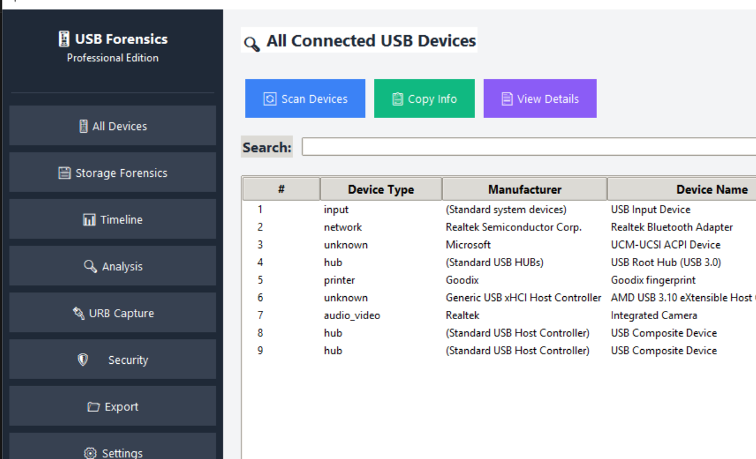
Figure 1: 01_devices_page.png
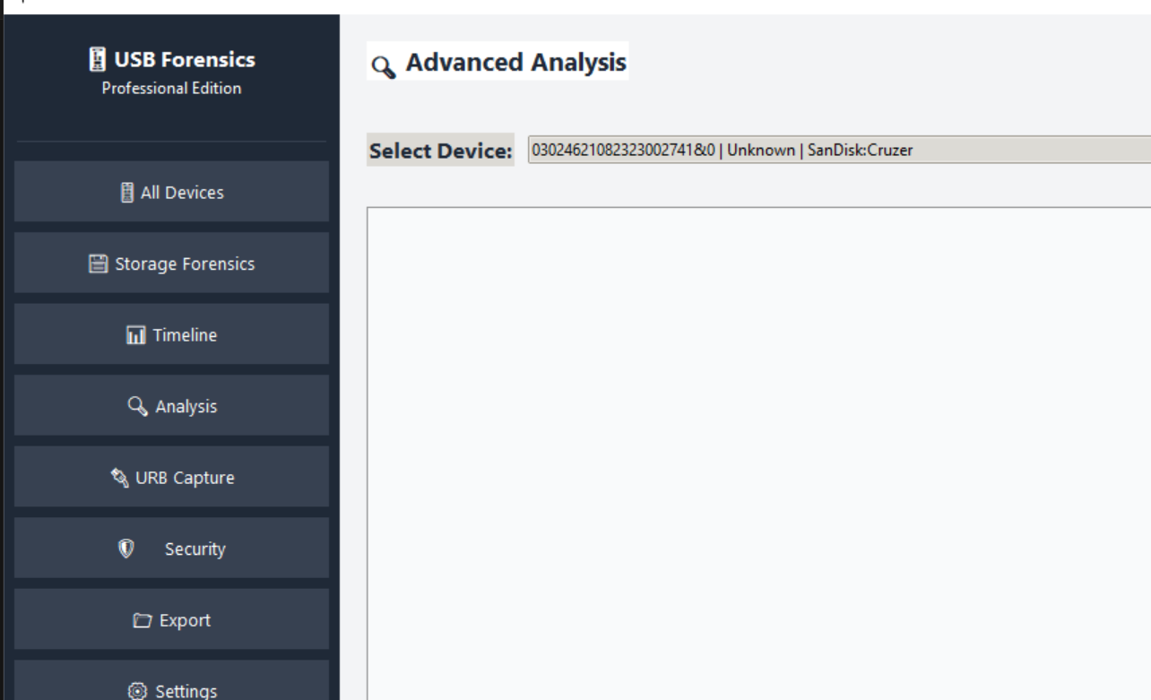
Figure 2: 02_analysis_page.png
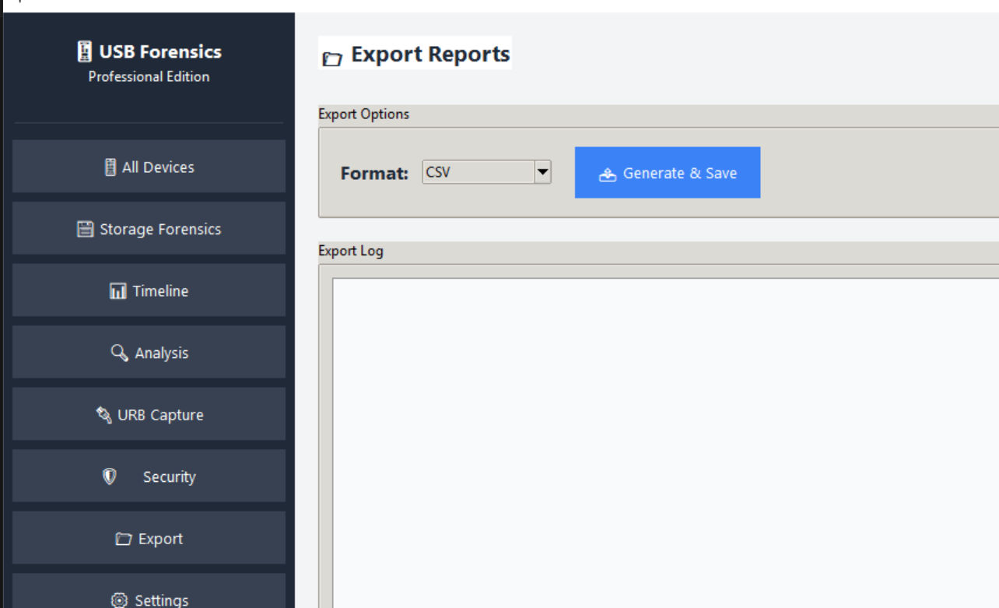
Figure 3: 03_export_page.png

